When we hit a request from the browser, then its default is get request. Because for post request we have to provide the body, and we cannot provide the body with the browser.

For post request, we can use post man tool.

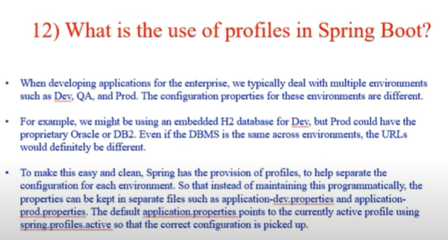

Use different ports in dev and prod.

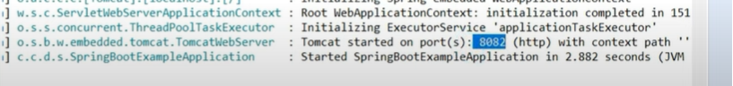

If we want to see more endpoints like what bean created etc, then add below line in application.properties.

